**Q.1. Create the following layout for your ecommerce website using external CSS.**

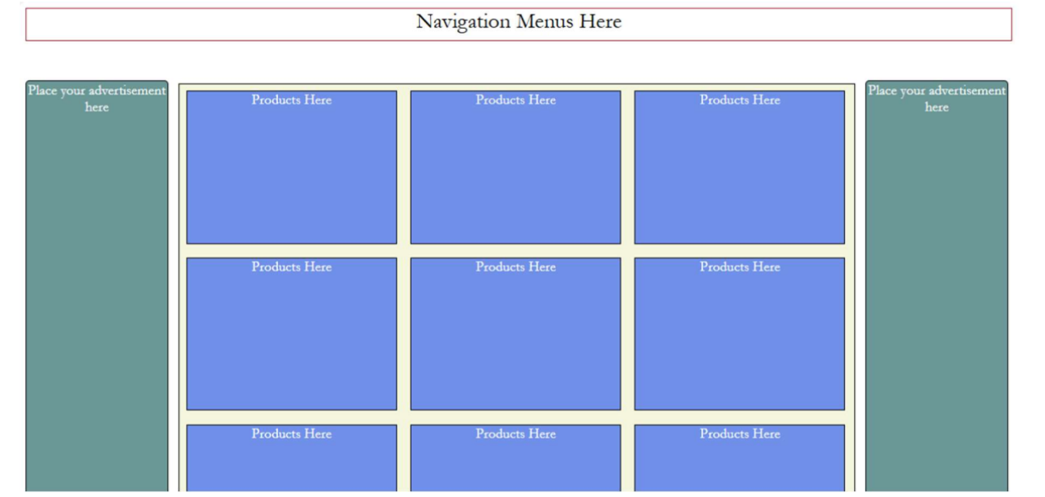

**Q.3. Use external CSS to design the form you created in the 1st Practical Session. The final form should resemble one given below. You may choose the colors and fonts as per your wish.**

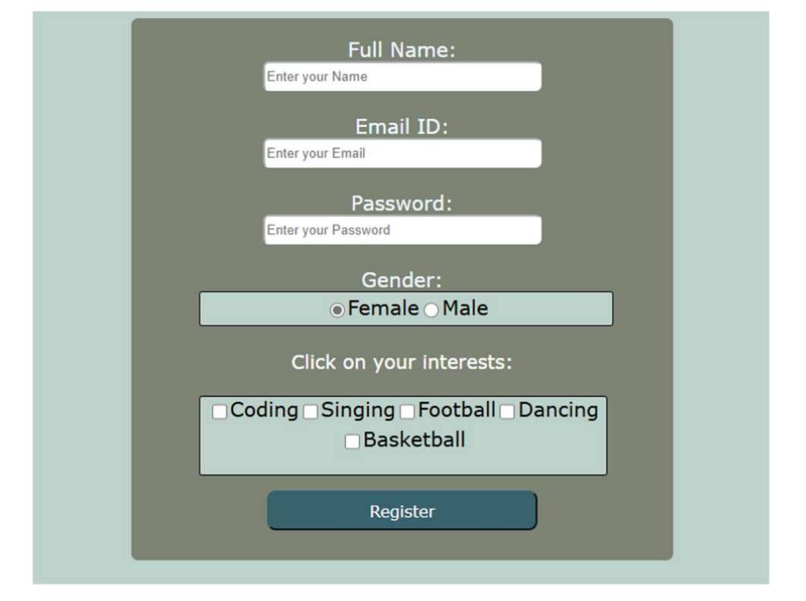

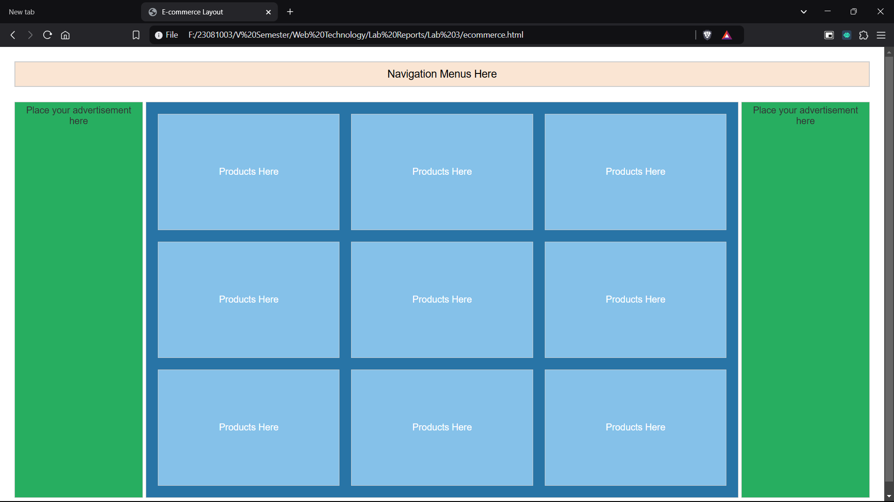**Output:**

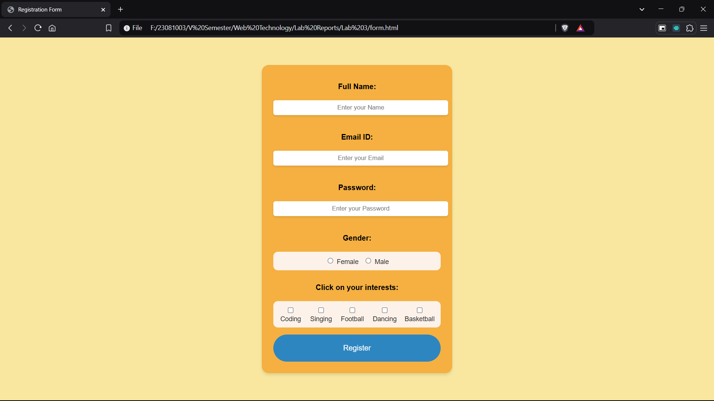**Output:**

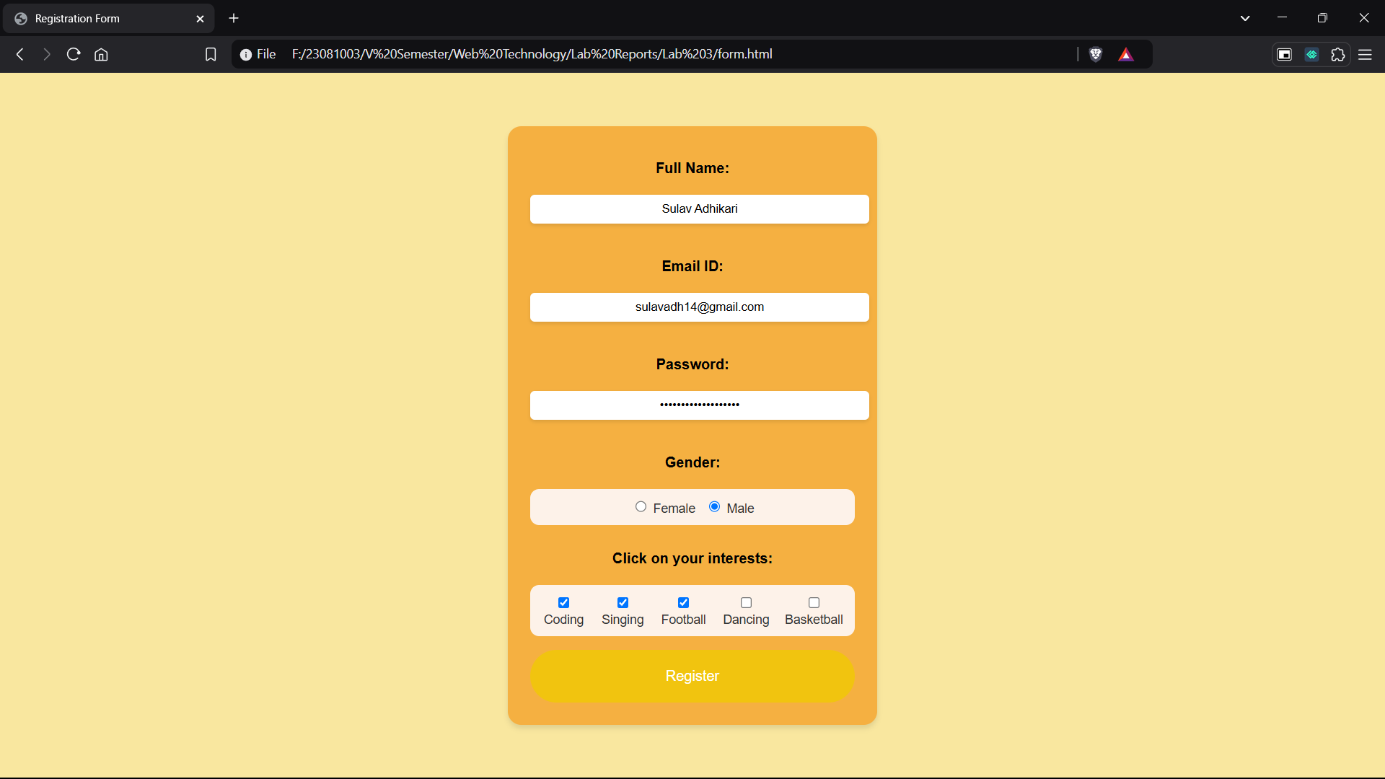

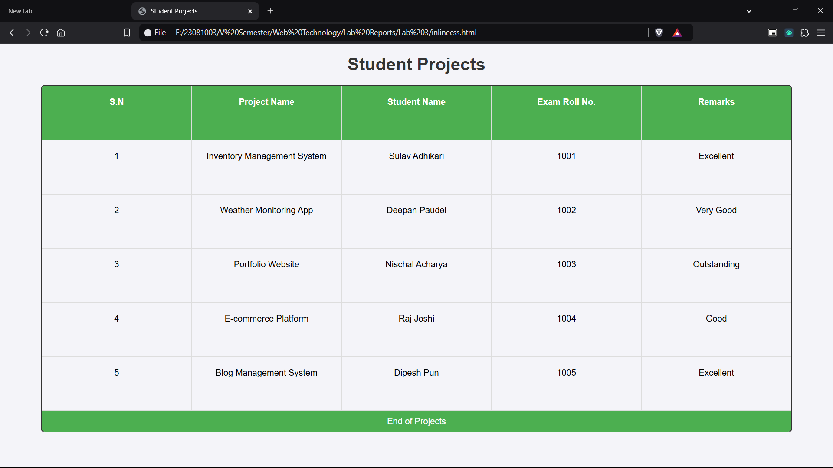**Output:**